Exercise 3:

English do exercise 3 (pair work) on the Photocopy "G a revival through jazz" (do in between 5 and 10 questions in the globality)

1. 1: Journalist: So, what where you’re feelings about this cyclone?
2. Singer: The cyclone was terrifying, but the worst was what happened to my belongings, I only have my ~~good~~ old faithful instrument and my clothes. Nothing else.
3. 2: Journalist: and how did you survive with just your clothes, and your instrument? How did you cope emotionally ~~survive~~?
4. Singer: At first it was very difficult because I had to start from zero ~~nothing~~. I didn’t know where my family was, I had no money, no phone, I only had my hands and my instruments with my voice to earn money, or at least express my feelings about the natural disaster that had struck us.
5. 3: Journalist: What kind of music did you sing?
6. Singer: I would play a knew fashion that ~~had been~~ was created after the disaster, it was called the new jazz revival.
7. 4: Journalist: That must have been a very helpful form of jazz, but please tell me more about the way you sung your music? We’re you singing on your own or with a Jazz band?
8. Singer: I was with other singer’s that emotionally had difficulties overcoming their emotions and so together we would write and play songs.
9. 5: Journalist: Did you play your music on stage or just for yourself?
10. Singer: My group and I would play on stage and sometimes improvise ~~k~~new tracks in live.
11. 6: Journalist: Did you record any of your music’s at the time?
12. Singer: unfortunately, we didn’t because we didn’t have the necessary equipment to. So, what you can hear nowadays has been recorded much later when we were much older.
13. 7: Journalist: did the music help you in the harder moments like when you had to rebuild your life?
14. Singer: yes, but what would happen was that some days we would play for everybody. On ~~and~~ other days it would be another band that would take our place like Lu Watters or Sid Le Protti's Barbary Coast or even The Turk Murphy Jazz Band.
15. 8: Journalist: Wow ~~these~~ those are some bands. I listened to a few of the myself. How long did it take you to recover from your emotional state after this hurricane?
16. Singer: I never totally recovered from this event. Even if we are used to having cyclone that destroy everything, we’ve never experience something, that strong and devastating.
17. 9 Journalist: Do you still play revival jazz nowadays?
18. Singer: yes, I do and it’s how I still earn my living.
19. 10 Journalist: do you still compose music nowadays?
20. No unfortunately I don’t.
21. Journalist: Well it was nice meeting you and hope to see you soon.
22. Singer: I hope so to. Goodbye
23. Journalist: Goodbye

Credits:

* <https://www.theguardian.com/music/2018/jun/16/kamasi-washington-interview-jazz-is-like-a-horse-you-can-ride-out-on-heaven-and-earth>
* <https://www.musicmusingsandsuch.com/musicmusingsandsuch/2018/8/8/feature-re-birth-of-the-cool-is-the-jazz-revival-here-to-stay>
* <https://www.youtube.com/watch?v=iuFNtGqel0I>
* <https://en.wikipedia.org/wiki/Terry_Waldo#Career>

an ordeal / a hardship = une situation difficile

exposé anglaise:

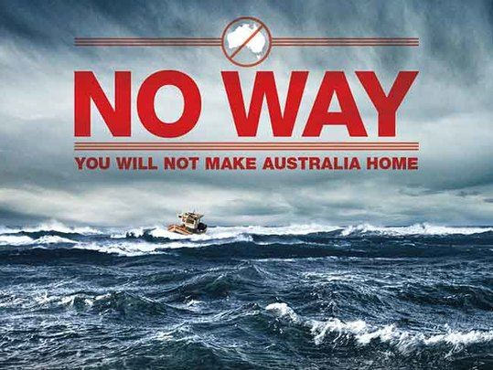

<https://www.irishcentral.com/opinion/cahirodoherty/australian-governments-anti-immigrant-poster-shocks-planet-video>

<https://bit.ly/2lVS9YP>

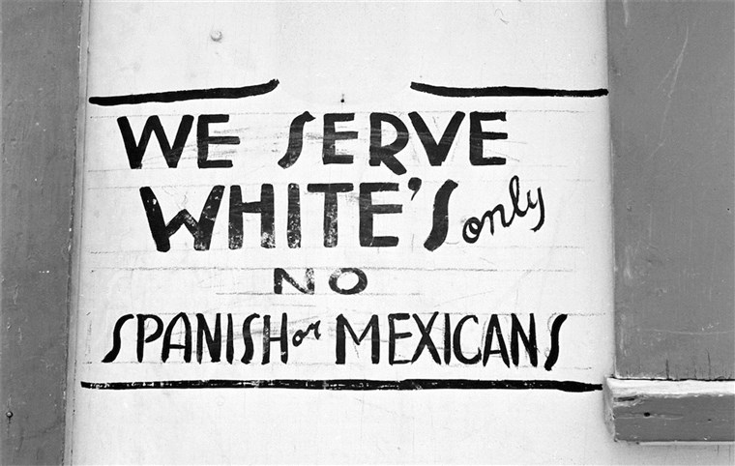

<https://bit.ly/2kkaajl> (site ayant l’image), <https://media4.s-nbcnews.com/j/newscms/2019_33/2023466/170602-russell-lee-segregation-ac-506p_6e00acc731f13c9216ae0a169e65a54e.fit-2000w.jpg> (l’image)

<https://bit.ly/2lNDZcu>

<https://www.youtube.com/watch?v=OIT0ucf_gys>

lyrics land of the free :

Oh oh oh oh, oh oh oh oh  
I'm standing crying (oh oh oh oh)  
I'm standing crying (oh oh oh oh)  
So how many daughters, tell me, how many sons  
Do we have to have to put in the ground  
Before we just break down and face it  
We got a problem with guns? (Oh oh oh oh)  
In the land of the free  
Down at the border, they're gonna put up a wall  
Concrete and Rebar Steel beams (I'm standing crying)  
High enough to keep all those filthy hands off  
Of our hopes and our dreams (I'm standing crying)  
People who just want the same things we do  
In the land of the free

Land of the free, land of the free  
In the land of the free  
Land of the free, land of the free  
Land of the free, land of the free  
In the land of the free  
Land of the free, land of the free  
Land of the free, land of the free  
Land of the free, land of the free  
In the land of the free (I'm standing crying)

We thought It would be interesting to compare this sign with a song against the construction of the wall on the Mexican-American border. First, it's important to explain the context. The construction of this wall was started after the end of the Mexican-American war, in 1848. The outcome is that Mexico loses around 50 percent of territory which is now California and Texas. Initially on the new border there is no wall, it is just marked at regular intervals by a pile of stones, its aim was to represent the imaginary wall. People could move freely. Then, 4 years later, in 1891, these piles of stones were replaced by white pillars As the US decide to map the border more accurately. At this point the wall was still imaginary. Then in 1897 in many places the US demolish buildings etc and impose there be a wide strip of no man’s land on either side of the border so that visibility is better to spot smuggling which is on the rise of everyday items to avoid import tax.

What is interesting is that through the history of the wall there have been many iterations and their purpose varied: So, let me take you to the early 1900s where this time it is actually the cattle the US want to control as ticks are spreading disease, what can stop it? A simple fence of course. This is then followed by a bigger fence which this time is to control immigration (Chinese, then Mexican, then German spies in the first WW). In 1918 saw big wire fence being built. But its aim was mostly to diffuse tension than stop people from crossing. The big change comes in 1940s as many Mexican immigrant’s cross to the US to work on the farms which is follow many illegal immigrants crossing to the US to look for work. The wall becomes a barbed wired metal fence in but in the 1990s These metal fences are made solid by reusing the metal landing helicopter mats from the Vietnam War.

On September 11th, 2001 the Twin Towers are hit leading to further tightening of immigration rules and the length of the wall expanded by five times. The harder it is to enter the US the more people are attempting to enter illegally. In turn this leads to more reinforcements of the borders and hence the wall.

More recently, a project suggested by Donald Trump has been to replace the walls made from the Vietnam War mats by much higher concrete coloured walls. Trump's proposal has been met with a lot of opposition and protest including films, works of art and also songs: so we chose the song “Land of the free” because it illustrates the horror, the violence, the reason for the construction of the wall. This music expresses the opinion of many Americans, Mexicans, strangers that think it is immoral to build a wall to stop humans from crossing borders. We think that even if they try to customise the wall it’s still a concrete wall it does not change what fundamentally the wall does. There have been many peaceful ways of expressing disapproval and this has also been done through music. If we take a look at the words of the song “Land of the free” we can notice that the song names America as “the land of free” and that the person that is not named but used in the song is a migrant that succeeded in his aim of crossing the border to get to America. If you listen to the words, you can notice that “I’m standing crying”, “Oh oh oh, oh oh oh” and “land of the free” appear quite frequently (every paragraph), meaning that the other people mentioned in the song are envying America and are desperate to join the other side of the wall. And this memory saddens the author who washes his truck in the Sinclair station, “Can’t wipe the wind-blow smile from across my face”. It upsets the author so much that he cries at the sight of the migrants, Mexicans trying to cross the border hoping for a better life.

Alternatively, other artists have tried to find ways to help people connect on both sides of the border wall. They didn’t necessarily break the law, or destroy the wall, but they tried to use the good sides of it to help separated families to make a connection. The wall isn’t only composed of Heli-mats there are also some places where there are vertical bars instead. The artists put a rectangular pink bar through the wall and so it balanced on either side creating a see-saw. This is just one of the many way’s artists have attempted to help families link.

Personal Opinion:

I think it is horrible to separate families, traumatic, to block people, to stop them from accessing freedom. I also think that what artists are doing to try and help families reunite even if a wall separates them is fantastic and should be maintained. Finally, I think that even if racism has been around for ever, it is essential to reduce it to a minimum or preferably end it for once and for all.

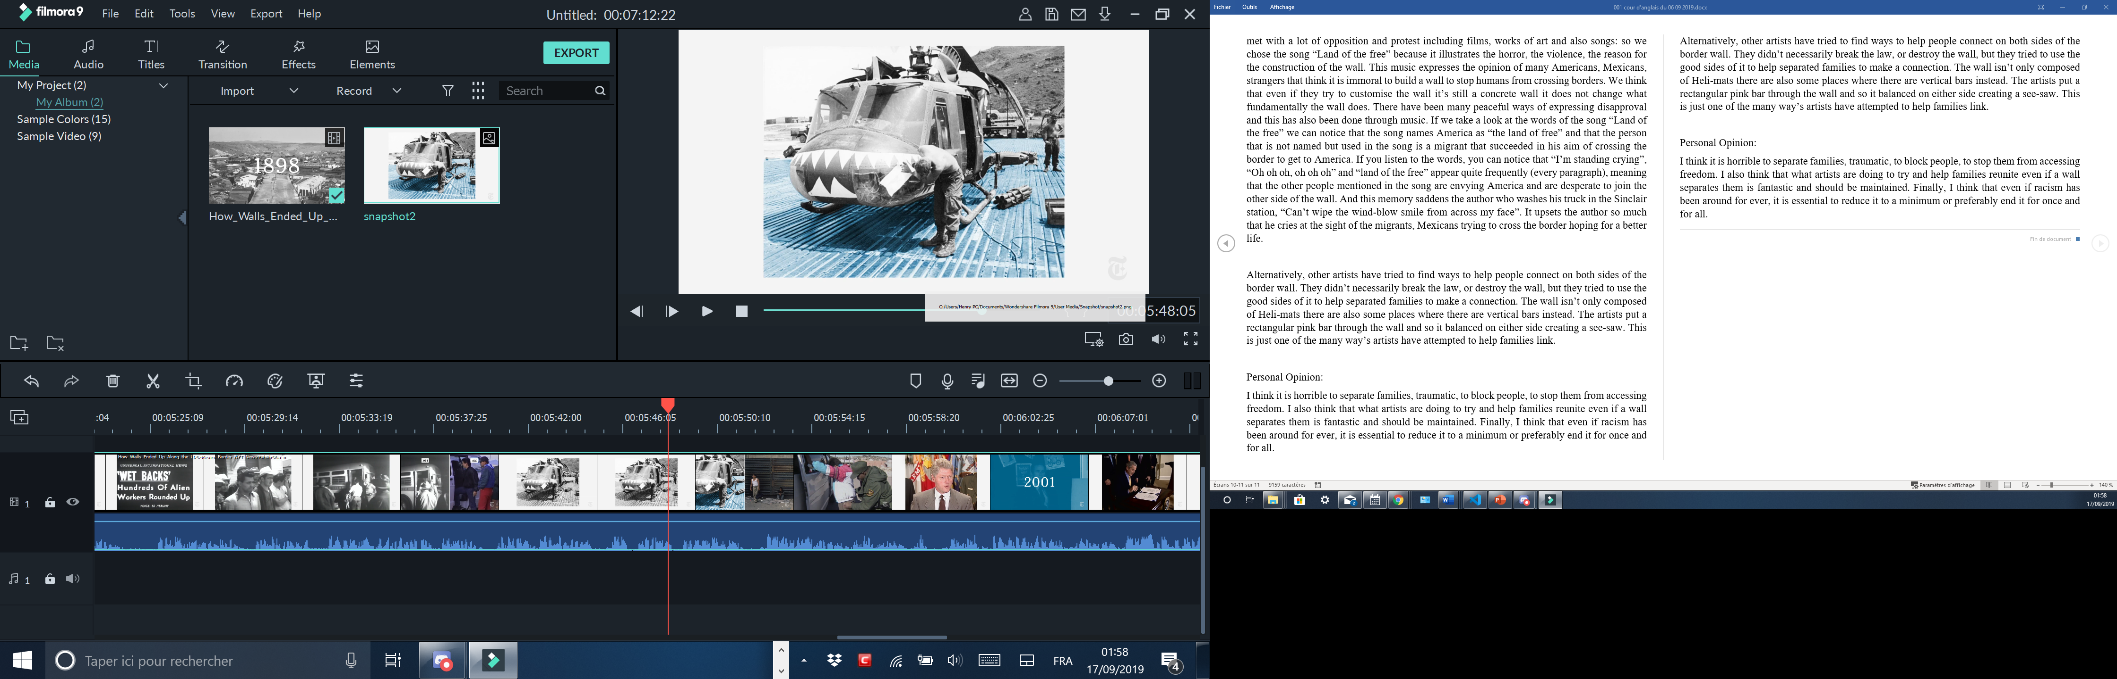

<https://img.20mn.fr/ndp7POGDSEqAc2due7L1cw/310x190_twin-towers-world-trade-center-11-septembre-2001.jpg>

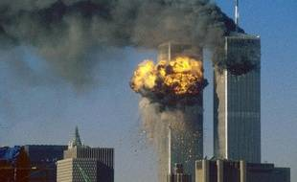  
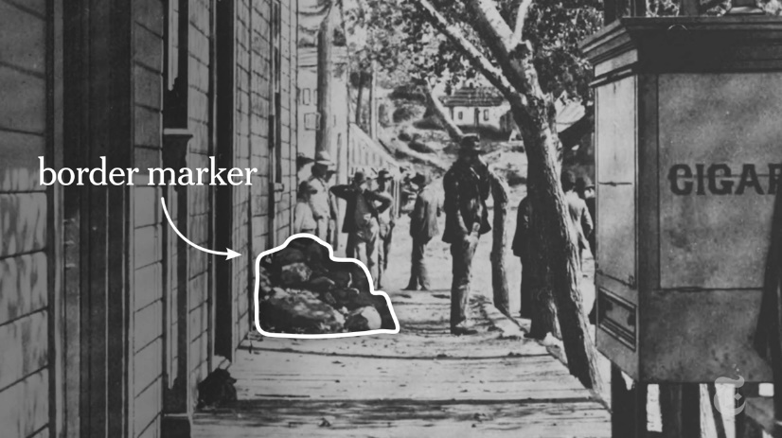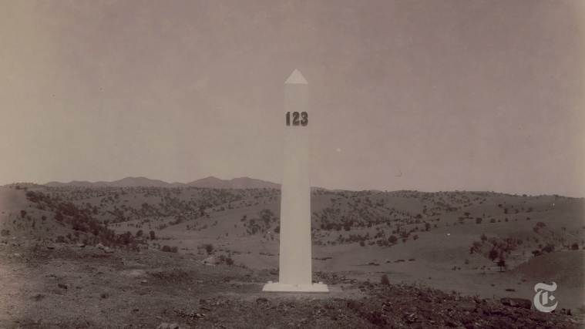

<https://www.google.com/url?sa=i&source=imgres&cd=&ved=2ahUKEwjo7t6pzdbkAhWdDWMBHcW0BjQQjRx6BAgBEAQ&url=https%3A%2F%2Fqz.com%2Fquartzy%2F1182972%2Ftrumps-border-wall-prototypes-are-art-argues-artist-christoph-buchel%2F&psig=AOvVaw0bodZZeKSQH-D7h18XxV1t&ust=1568766643456622>

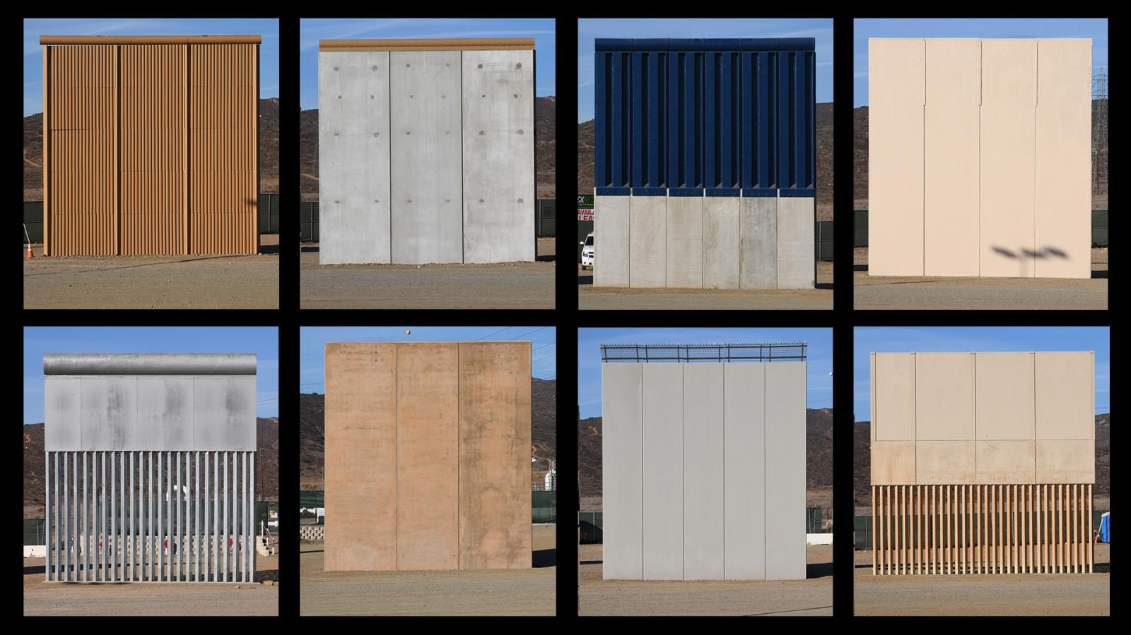

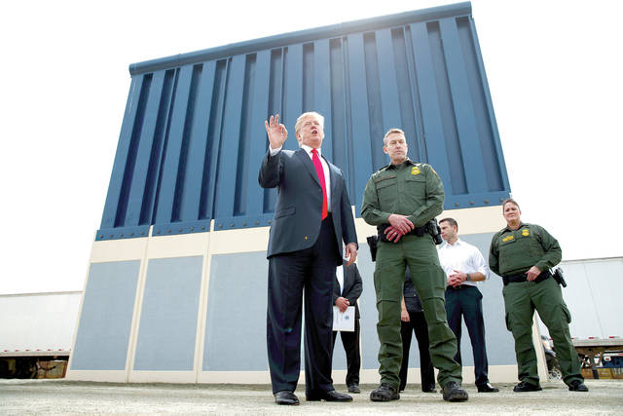

<https://www.hawaiitribune-herald.com/wp-content/uploads/2018/03/web1_AP18086723862996.jpg>

Friday, 27 September 2019

Voc:

A scrounger = a thief, a theft, a robber

A burglar = a thief who enters your house

A shareholder = stockholder

Impeachment = destitution.

To fire = to lay-off = to dismiss = to make people redundant

Touchy = sensitive

Ex 1 p 142: (Another way)

a)

My reaction is that I’m surprised to see the Statue of Liberty with its hand up, indicating a refusal of something or somebody. The position of the hand is such that it says ‘stop’ like a policeman controlling the traffic. The angle of the illustration makes you feel small, looking up at the statue.

b)

The message “Who gets to be an American?” is unusual because the Americans themselves are a nation of immigrants which seems incongruous with their history. The debate within the country is highly controversial and dividing the country – whereas before everybody who wanted to enter the US could and start a new life. They were pioneers starting in the 17th century.

2

a)

The line “the immigration debate that is dividing the nation” is the message on the Times cover, the poem Refugees expresses two opposing opinions depending on which direction you read the poem. It is written by Brian Bilston and I think he believes that immigrants should be helped in the U.S. First you read the poem and you feel it is unjust but once you read it the other way you realise how clever it is – it’s a powerful message and technique to express two opposing views.

b)

“[People around the world express more support for taking in refugees than immigrants](https://www.pewresearch.org/fact-tank/2019/08/09/people-around-the-world-express-more-support-for-taking-in-refugees-than-immigrants/)”

“[Growing share of Republicans say U.S. risks losing its identity if it is too open to foreigners](https://www.pewresearch.org/fact-tank/2019/07/17/growing-share-of-republicans-say-u-s-risks-losing-its-identity-if-it-is-too-open-to-foreigners/)”

“Refugee admissions into the U.S. have declined substantially during Donald Trump’s presidency.”

Trump and the Mexican wall

3

Neither of them because the poem has a two-way sense, in one way it is against immigration but in the other way it is for immigration. There are always two sides to an argument, two ways of viewing things.

Voc

To realise = se render conte

To make a dream come true = rendre un rêve réalité

Painstaking = hard-working

To be devoted to = être dévoué à

To endow = to receive

Boundaries = the border

Summary of the text: The pursuit of happiness

In the text Einstein say’s that the Americans aren’t dollar chasers, the students aren’t looking and bending over backwards to earn money. He says that they are good scientists even if some are better than other. He also say’s worship a god. That most of the people are calm and live a normal calm life. For Einstein, students link superpowers to the mind and character. This is what Einstein wanted. And that the previous descriptions (materialistic country) isn’t a true fact.

To look for = chercher

Unbearable = invivable

A pre-conceived idea = a stereotype, a cliché.

Summary of the text “born in the USA”:

In the text, the author mentions that he came to America hoping for a better life, He didn’t want to become an Austrian policeman like his father. So, he went to America and a tried to realise his “American dream”. To realise this dream, he was helped by very generous Americans that allowed him to go beyond his thoughts. He is for immigration nut thinks that if you want to integrate America, you must work and give something back. Then he gives a few steps of advice, like learning to speak English. He arrived at Hollywood in 1968 speaking a little bit of English and soon enough took speaking lessons to be able to progress in his job. The next piece of advice is to get involved in the politics of the country, learn about it, think, … He also says that not everybody is capable of being albert Einstein, but he quotes a martin Luther King Jr sentence ‘Anybody can be great, because anybody can serve”. The third advice is that you must continuously learn and be informed about democracy. The last advice that he gives us is to “give something back”, in other terms, serve the nation.

To pay a tribute to = être redevable

The common points between the two texts are that both of the characters want to enter the US. Both have had their own idea of the USA and once in there they discover that their idea is not completely true.

To buy at bulk

To lay off = to fire

An anthem

A retailer ≠ wholesaler

A stockholder

A melting pot = a land of immigration

Income = revenue

Premises= the place

To be on the premises = to be on the spot

Findings=results=outcomes

To result in (something) = résulter en

To generate = provoquer

A figure/ a number = un nombre

To figure out = trouver la solution

To work out/to setle = faire du sport

To deal with =

To handle =

Bold = audacieu, en gras

Survey findings = results = outcomes

A survey = an opinion poll

A shaft = un mat

Timber = building wood

To look forward to + verb in ing =

To hear from = prendre des Nouvelles

In a near future = dans un future proche

A = schéma

Articles:

If a noun is abstract life/war/nature/freedom/… there is no article.

Concerning the country:

A singular country has no article

A plural country has an article.

**Grammar:**

~~.~~

1) He lives in America 🡪 Present simple

In English, if you use for or since (depui) in English, you have to use the present perfect. You can’t say : ~~He lives in America for two years~~, you must say:

How long +Present perfect

For + Present perfect

He has in America for 6 years 🡪 it’s still true

He lived in Russia for 5 months;6 years 🡪 Past simple + For =

To cluster = to gather

How to write a letter

From to

Ref subject x Date

Opening salutation (Dear Sir, Madam; Dear Mr James; Dear John)

Closing salutation (yours faithfully; yours sincerely; Best Regards)

A lecture = a conference

To sum up = to summarise

To give a summary of

To resume = to start again

A resumption = une reprise

One phenomenon 🡪 2 phenomena

A crisis = crises

A mouse = mice

Wide ≠ narrow

To be narrow-minded ≠ to be open-minded

Quand les poules auront des dents = and pigs might fly

Avoir un chat dans la gorge = to have a frog in the throat

To call a spade a spade = appeller un chat un chat.

A wholesaler = un grossiste

A retailer = un vendeur

To suit = to fit

At dawn = au crépuscule

At dusk = au soir

a) The best and brightest students, researchers are attracted by the US intellectual opportunities.

b) There are 3 times more foreign students studying in the us than Americans studying abroad.

c) No, Foreign students generally pay full price.

d) The American students get financial aid from the university who benefits from the tuition fees paid by the foreign students. And The foreign students also enriched the university experience for Americans themselves.

e) They do advertising for the American schools and recommend them to their families and friends. And they can influence their countries foreign policy accordingly.

f) The number of foreign students is decreasing due to the international competition between different universities in other countries. The second reason is that it is harder to get an American visa to be able to study in America.

g) a degree today is more sophisticated and gives you better value than 20 years ago and it’s the same for the car.

h) universities have improved and made their courses more attractive and its cans be easier for students to get a visa, US universities need to do the same.

To hire = employ / to take on

To hire = to rent

A downside = a drawback

A counterpart = somebody who has the same job as somebody else

Training = la formation

A training course = un cour intensif

An internship = un stage en entreprise

Unemployment = le chômage

To be unemployed = to be out of work

To be retired = être à la retraite

Retirement = la retraite

A tax haven = un paradis fiscal

A tax evasion = evasion fiscal

The laundry = the wash

Money laundering = le blanchiment d’argent

To make money = faire de l’argent

To make a loss = perdre de l’argent

Loose = désseré

Turnover = le revenu

Staff turnover = le changement du personnel

To make up for lost (revenue/time) = rattraper (le temps/l’argent) perdu

To make up = inventer/to invent

To outsource = externaliser

Outsourcing = externalisation

Affordable = to have the means

Public and private spaces

To take a sick leave = prendre un congé maladie

To take a maternity leave = prendre un congé maladie

To take the French leave = filer à l’anglaise

To give birth = to deliver

To be pregnant = to expect

To be in labour = être dans les douleurs de l’accouchement

A surrogate teacher = un professeur de substitution

A deputy Prime minister = vice-premier ministre

A surrogate mother = Une mère porteuse

A blended family = une famille recomposée

Abortion = l’avortement

AIDS = le Sida

To set an example = mettre un exemple

To deter from = to prevent/stop from

Summary of the text:

Jacinda Arden, the New Zealand prime minister, has just returned to work after having had a baby and taking six weeks off for maternity leave. She is only the second leader of the country to have had a baby while in office. She considers herself very lucky and privileged, she is fortunate to have a partner who can look after the baby while on prime ministerial duties including speaking at the UN in New York where the baby will go with her on the trip. She said we will make it work, it’s about meeting the baby’s needs and not compromising how well she does her job.

To climb the social lader = to climb the social scale

Hierarchy = hiérarchie

CEO = chief executive officer

A well-paying job = to be well paid

A salary = wages

Labour (factory) ≠ workforce (in a company)

Business card = carte de travail

A glass ceiling = the maximum earnable

To be worth it = valoir la peine

To pay attention to = faire attention à

To make ends meet = joindre les deux bouts

Privacy = l’intimité

To fulfil dreams = accomplire des rêves

To struggle for = to fight for

To let down = laisser tomber

To tackle a problem = to deal with

To solve = to manage/to sort out/to figure out

An assignment = a mission (une tache)

An assignee = the person who does the assignment

To set foot in = metre le pied dans le plat

To be out of reach = hors d’ateinte

A degree = a diploma

To set sites to high = to have to high expectations

Peps and stamina = to have a lot of energy

Thistle = les chardons

To search a house = to seaze

To search = foullier

A research engine = un moteur de recherche

A warrant = un garantie

A guarantee = a warranty

An oath = un serment

To be caught red handed = être pris la main dans le sac

To be at steak = ce qui est en jeu

To wire = mettre sur écoute

To bug = mettre sur écoute

To break = ne pas enfreindre la …

A breach a contract = ne pas respecter un contrat

Summary of right to privacy:

In the letter from Tim Cook, Apple refuses to unlock a criminal’s iPhone, as evidence, because it meant that the firm would have to breach their own security rules, if they were to comply with the FBI and build a backdoor into the phone for them. This brings up another concern, being that the government would ask Apple to then build a surveillance software, this could be opened to abuse and would breach people’s privacy. In no way did Apple condone what the criminal did, the shooting in San Bernardino, but it was about protecting the security of their customers. Apple was respecting the Fourth Amendment.

The Fourth Amendment is there to ensure the right to privacy of individuals and that therefore nobody can search, or somebody’s belongings seize without proof or authorisation. Private information can make a difference between life and death, sacrificing our rights to privacy can have disastrous consequences. The “Stop-and-frisk” strategy in New York, was considered unconstitutional by a judge because it was focussing on black and Hispanic people. In a different from court ruling, the result was the opposite : drugs testing laws have been upheld allowing the athletes to be tested while still at high school.

A balance sheet = un bilan

To soar, To rocket, To boom = to go up very quickly ≠ to plummet = to go down quickly, to colapse

Traners = snickers

To be on a training course

To run a store

Steady = stable

To sew = to take to court = to take the mater further

To file suit = a trial

A suit = a case

to widen = to extend = to become bigger

a discrepancy = a gap

a counterpart = somebody who has the same job as you.

To climb the social scale or ladder = progresser dans une companie

To outweigh = avoir plus d’impacte, dépasser

Hunger problems = starvation famine

To starve to death = mourrir de faim

To be selfish = être égoiste

Selfishness = l’égoisme

To go shopping spree = faire du shopping frénésie

Reshoring = moving back companies to the original country.

Not to waste any food = ne gacher aucune nourriture

a cliché = a preconceived idea

a baised idea

a tyre = un pneu

to file lawsuit = to file claims

to run out of, to be short of, to lack = manquer de

to lack = manquer de

tu be underpayed = être sous-payer

to be overpayed = être surpayer

a sweatshop = to exploit somebody without paying them

**Summary of the text Nation.**

When Claudia Renati’s husband got badly injured and that the company he worked for crashed a year later, she urgently felt the need to climb the social ladder and be better payed in her company, she wanted to become a manager, but the only two elements she was offered was to be able to have a training course and if she wanted to be able to increase her rank, and so, run her own store, she had to go to Alaska which was just not an option. Every time she applied for the job, a peace would be torn away from her as every single time, the “white-boy frat”, often worse than her, would be qualified. She even once tried threatening her boos, that, if he didn’t promote her, she would go to another Sam’s club. She also pointed out that she had trained many people who had been graduated without having to uproot to Alaska. But these two arguments didn’t budge her boss. But she isn’t the only woman to whom that disappointing experience happened. Some other women had relocated through four different places in Virginia. In this company, men are promoted by a tap on the shoulder and women have no chance whatsoever. She left the company in 2002 and planned to file a law suite in the months to come. Renati was one of the first to start joining complaints against the Walmart company. Besides the fact that discriminating female employees has been illegal since the 1960s, this law is completely ignored by big companies such as Walmart.

Space

To take place in, To happen = to occur

Presently = à l’heure actuelle

Actually = in fact

Health = la santée

To draw up

To take measures = to take action.

To suffer from discrimination

To die of huger

A candidate or an applicant = somebody who applies for a job.

**Citizenship and the virtual worlds**

A Whistle-blower = un lanceur d’alerte

To spread Rumour/rumor = répendre des rumeures

The headline is splashing across the front page

A tabloid = journaux à sensation

To gossip = raconteur

An Anchorman = un présentateur

To fool = cheat

A tip= an advice

To spot = to find = to decipher = to decript

Outrageous= shocking

To be comforted = to be relieved

To soothed

Relevant ≠ irrelevant

Up to the point

Weird ≠ bizarre

Strange = outlandish

To have pre-concieved ideas = to be biased

To believe = belief

To be far-fechted = tire par les cheveux

Improbable =improbable

**Beware, Beware of Fake News, because it is all around Us**.

Fake News is what allows some newspapers to attract customers, but it is also a way to persuade, convey fake messages or bully somebody whom you don’t like. It is another way to punish or criticise. It is a way to intoxicate information, to discredit newspapers who don’t necessarily cross sources. If we take the fake news: « A woman named her daughter after a supermarket » is False, because, imagine that you’re looking for your child, and ask « have you seen Waitrose? ». This would lead to a terrible quiproquo.

To avoid being mistaken by fraudulous or faulty websites, there are now new aps and software that scan the pages or that have a database of the software that will tell you if the website is legit to be trusted or not. These add-ons, sometimes developed by very known newspapers will help you see through this whole mess that is called online newspapers or blogs.

Websites like *Twitter*, *Facebook*, *Tumblr*, *Instagram*, *Snapchat* can be just as toxic than the newspapers. But for this, unfortunately, there are no add-ons or little apps that have crossed references for you. So, if you know, that, what the author writes can manly be trusted, then go on, you won’t need to cross references every single time.

Some printed of the road newspapers will possibly lead you to have to cross refences to make sure that the information is legit, if the newspaper is from a serious company, like *Le monde* or *Science et vie Junior*, then you can sit back and relax, and play a board game afterwards.

TV channels like *France: info* or *24-hour news* might lead you to check their sources because, giving non-stop news is difficult to provide without risking that a bit of few fake news slips in. That’s why it is important to cross references to: learn more and possibly stop watching that news.

This is why watching reliable channels is just as important than reading reliable newspapers and blogs, checking the spelling mistakes and the level of language. Especially with the coronavirus going around, stay safe and well informed

A piece of news

Information, furniture, luggage

Advice, news

It makes sense

A threat

To threaten

To be careful, to pay attention

To be aware of

Harmless

Harmful

To do harm

Reliable

To trust somebody, to rely on, to be confident in

Confidence.

Relentlessly = all the time

To be shunned = to be rejected

Ex p 90:

1)

Trump hates the media and has discredited it by constantly criticizing it. He also has popularised the term fake news.

2)

The American teenagers also think that the news is biased, unreliable. Teenagers question the credibility of traditional news.

3)

Emma Neely, (19 years old):

Doesn’t believe there are any neutral organizations.

Angie, (16 years old):

“news media cannot be trusted”, “Things are not what they seem”

Sally, (17 years old):

“not to trust media”, media “say what they want to say”, doesn’t feel that media “say the truth as it is”.

Media, they have the power to make the innocent guilty and the guilty innocent.

A culprit = a guilty personne

Internet has been a boom and a curse for teenagers

The ins and out = les tenans et les aboutissants d’un problème.

Identities and exchanges:

Summary

The extract takes place in Mr Nguyen shop, where Baba, the protagonist’s father, had tried to pay for oranges with a check and had gotten angry because Mr Nguyen asked to see his ID. The protagonist had to explain to his father that it was the laws that required the seller to see the Id of the customer and that trust did not exist in this country.

Answer to the question:

What's the connection between the text and the title: identities and exchanges?

The connection is that they are considered as immigrants there is no trust bond in between Baba and Mr Nguyen compared to when they would go and buy naan bred back home. This is what I think the connection is, the minute you’re in a new country, you’re considered as an immigrant and not as a local.

Quotes:

1 Thomas Paine, philosopher said:

* The world is my country, all mankind are my brethren and to do good is my religion.

2 Ban-Ki-Moon, former Secretary General of the UNO said:

* Migration is an expression of the human aspiration for dignity, safety and a better future. It is part of the social fabric of our very make-up as a human family.

Explain which Quote is the most relevant to the theme (identities and exchanges)

The Quote from Thomas Pain is the one I find most relevant because It gives an overall definition of mankind and especially about identities and exchanges. The first part, “the world is my country”, means, to me, that there are no borders when speaking of identity. You can travel wherever you want, live wherever you wish, there is no definitive home anymore. From one day to the next you can change location without necessarily losing your job. And even if it were the case, you can adapt, retrain, and start again. The second part of the quote “all mankind are my brethren” could be seen as a partial loss of identity by becoming part of a brotherhood or on the contrary it could reinforce your identity because you feel where you belong and are accepted. You could argue that when Thomas Pain considers mankind as his brethren there is a loss of identity as there are no longer any defining borders. The final part of the quote, “and to do good is my religion” is also an important part of his identity and must by default entail exchanges with others.

#Super Multitasking Font Sheet

##The new way of presenting fonts to a customer

This is a new style of font sheet; It allows you to show to your customer all the fonts of the pack he has acquired.

***

##Changing the size of the font (coming soon!!)

This is the Aa=( _number box_ ) on the first line, it is a common element that allows the customer to adjust the size of the font to as many times as he wishes.

_PS:_ This number box might become, in the future versions, a slider ranged from __1 to 100 px__ .

***

##The First Toggle

The first option, ( _the only one that will be displayed when the customer will land on the page_ ) will allow him the view a specific font from the scroll down list on top of the result box ( _very long box_ ).

***

##The Main Three Toggles

Under the font size there a three toggle switches enabling the customer to whow or hide a specific par to the page, there are three switches:

- Hide the customisable box

- Show all the fonts

- Show the customisable text

***

##The Second Main Toggle

If the customer wishes to view all of the fonts at the same time, he can enable the toggle `Show all the fonts`

Its effect will be to display the second bloc containing all the fonts.

***

##The Third main Toggle

The customer can try his own letters for a specific font ( _available from another scroll down list_ ).

***

##Coming Up!

In the __next versions__ to come (on this pen) the customer will be able to show/hide a specific part of the display (via toggle buttons):

The possibilities will be:

- Sentence

- Accents

- Digits

- Greek

- Dashes

- Maths

- Punctuation

- Symbols

- Crossed

- Arrows

- Currency

- Trademarks

- Other letters

- Other bundles of characters

##And

PS: Better graphics are to come in the next updates.

I Hope you like the concept, if you do so, please tell me in the comments.

***

##Credits

Henry Letellier

Please Credit me in the bottom, or somewhere in the page (user side) and in a visible color. ( _not white on white_ for example.)

Allowed